ANOTIDAISHE BLESSED ZHOU
25/SCA/BCDS/019
00P USING JAVA

- Write a program to find factorial of n number.

import java.util.Scanner;

public class FactorialRecursive {
public static long factorial(int n) {
if (n == 0 || n == 1) {
return 1;
} else {
return n * factorial(n - 1);
}
}

public static void main(String[] args) {
Scanner sc = new Scanner(System.in);
System.out.print("Enter a number: ");
int num = sc.nextInt();
System.out.println("Factorial of " + num + " is " + factorial(num));
sc.close();
}
}

OUTPUT

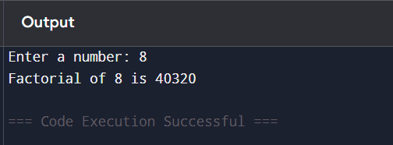

- Write a program to find the sequence of Fibonacci series up to n terms

import java.util.Scanner;

public class FibonacciSeries {
public static void main(String[] args) {
Scanner sc = new Scanner(System.in);

System.out.print("Enter the number of terms: ");
int n = sc.nextInt();

int first = 0, second = 1;

System.out.println("Fibonacci Series up to " + n + " terms:");

for (int i = 1; i <= n; i++) {
System.out.print(first + " ");
int next = first + second;
first = second;
second = next;
}

sc.close();
}
}

OUTPUT

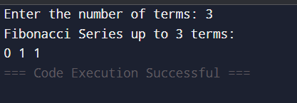

- Write a program to check whether given number is palindrome or not.

import java.util.Scanner;

public class PalindromeCheck {
public static void main(String[] args) {
Scanner sc = new Scanner(System.in);

System.out.print("Enter a number: ");
int num = sc.nextInt();
int original = num;
int reversed = 0;

while (num != 0) {
int digit = num % 10;
reversed = reversed * 10 + digit;
num /= 10;
}

if (original == reversed) {
System.out.println(original + " is a Palindrome.");
} else {
System.out.println(original + " is NOT a Palindrome.");
}

sc.close();
}
}

OUTPUT
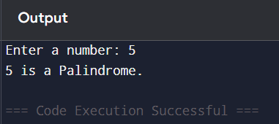

- Write a program to find HCF of two numbers.

import java.util.Scanner;

public class HCF {
public static int findHCF(int a, int b) {
while (b != 0) {
int temp = b;
b = a % b;
a = temp;
}
return a;
}

public static void main(String[] args) {
Scanner sc = new Scanner(System.in);

System.out.print("Enter first number: ");
int num1 = sc.nextInt();

System.out.print("Enter second number: ");
int num2 = sc.nextInt();

int hcf = findHCF(num1, num2);
System.out.println("HCF of " + num1 + " and " + num2 + " is: " + hcf);

sc.close();
}
}

OUTPUT

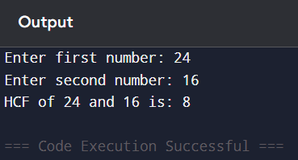

- Write a Java Program that will display the sum of 1+1/2+1/3…..+1/n.

import java.util.Scanner;

public class HarmonicSeriesSum {
public static void main(String[] args) {
Scanner sc = new Scanner(System.in);

System.out.print("Enter the value of n: ");
int n = sc.nextInt();

double sum = 0.0;

for (int i = 1; i <= n; i++) {
sum += 1.0 / i;
}

System.out.println("Sum of series up to " + n + " terms is: " + sum);
sc.close();
}}
OUTPUT

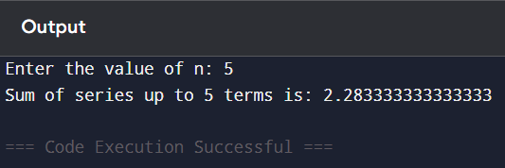
- Write a Java Program to find product of two matrices.

import java.util.Scanner;

public class MatrixMultiplication {
public static void main(String[] args) {
Scanner sc = new Scanner(System.in);

// Input dimensions
System.out.print("Enter number of rows of first matrix: ");
int r1 = sc.nextInt();
System.out.print("Enter number of columns of first matrix: ");
int c1 = sc.nextInt();

System.out.print("Enter number of rows of second matrix: ");
int r2 = sc.nextInt();
System.out.print("Enter number of columns of second matrix: ");
int c2 = sc.nextInt();

// Check if multiplication is possible
if (c1 != r2) {
System.out.println("Matrix multiplication not possible! Columns of first must equal rows of second.");
return;
}

int[][] A = new int[r1][c1];
int[][] B = new int[r2][c2];
int[][] C = new int[r1][c2]; // Result matrix

// Input first matrix
System.out.println("Enter elements of first matrix:");
for (int i = 0; i < r1; i++) {
for (int j = 0; j < c1; j++) {
A[i][j] = sc.nextInt();
}
}

// Input second matrix
System.out.println("Enter elements of second matrix:");
for (int i = 0; i < r2; i++) {
for (int j = 0; j < c2; j++) {
B[i][j] = sc.nextInt();
}
}

// Matrix multiplication
for (int i = 0; i < r1; i++) {
for (int j = 0; j < c2; j++) {
C[i][j] = 0;
for (int k = 0; k < c1; k++) {
C[i][j] += A[i][k] * B[k][j];
}
}
}

// Display result
System.out.println("Product of the two matrices is:");
for (int i = 0; i < r1; i++) {
for (int j = 0; j < c2; j++) {
System.out.print(C[i][j] + " ");
}
System.out.println();
}

sc.close();
}
}

OUTPUT

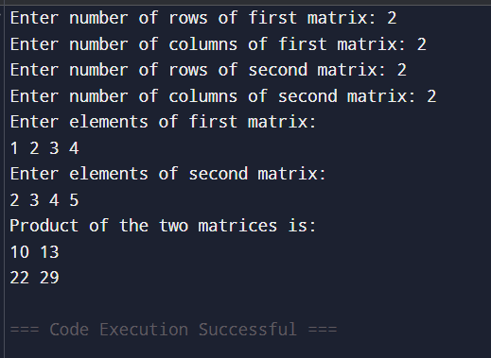

- Write a Java Program to find sum and subtraction of two matrices.

import java.util.Scanner;

public class MatrixSumSubtraction {
public static void main(String[] args) {
Scanner sc = new Scanner(System.in);

// Input dimensions
System.out.print("Enter number of rows: ");
int rows = sc.nextInt();
System.out.print("Enter number of columns: ");
int cols = sc.nextInt();

int[][] A = new int[rows][cols];
int[][] B = new int[rows][cols];
int[][] sum = new int[rows][cols];
int[][] diff = new int[rows][cols];

// Input first matrix
System.out.println("Enter elements of first matrix:");
for (int i = 0; i < rows; i++) {
for (int j = 0; j < cols; j++) {
A[i][j] = sc.nextInt();
}
}

// Input second matrix
System.out.println("Enter elements of second matrix:");
for (int i = 0; i < rows; i++) {
for (int j = 0; j < cols; j++) {
B[i][j] = sc.nextInt();
}
}

// Calculate sum and difference
for (int i = 0; i < rows; i++) {
for (int j = 0; j < cols; j++) {
sum[i][j] = A[i][j] + B[i][j];
diff[i][j] = A[i][j] - B[i][j];
}
}

// Display sum
System.out.println("Sum of matrices:");
for (int i = 0; i < rows; i++) {
for (int j = 0; j < cols; j++) {
System.out.print(sum[i][j] + " ");
}
System.out.println();
}

// Display difference
System.out.println("Subtraction of matrices (A - B):");
for (int i = 0; i < rows; i++) {
for (int j = 0; j < cols; j++) {
System.out.print(diff[i][j] + " ");
}
System.out.println();
}

sc.close();
}
}

OUTPUT

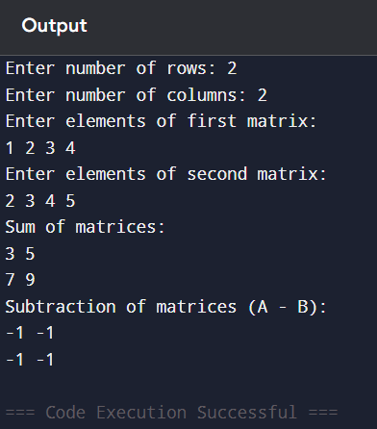

- Write a Java Program to sort the list in ascending Order.
import java.util.Scanner;

public class SortAscending {
public static void main(String[] args) {
Scanner sc = new Scanner(System.in);

System.out.print("Enter the number of elements: ");
int n = sc.nextInt();
int[] arr = new int[n];

System.out.println("Enter the elements:");
for (int i = 0; i < n; i++) {
arr[i] = sc.nextInt();
}

// Sorting using Bubble Sort
for (int i = 0; i < n - 1; i++) {
for (int j = 0; j < n - i - 1; j++) {
if (arr[j] > arr[j + 1]) {
// Swap
int temp = arr[j];
arr[j] = arr[j + 1];
arr[j + 1] = temp;
}
}
}

System.out.println("Sorted list in ascending order:");
for (int i = 0; i < n; i++) {
System.out.print(arr[i] + " ");
}

sc.close();
}
}

OUTPUT

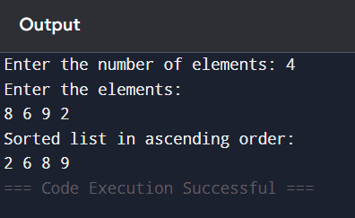

- Write a Java Program to convert decimal into binary number.

import java.util.Scanner;

public class DecimalToBinary {
public static void main(String[] args) {
Scanner sc = new Scanner(System.in);

System.out.print("Enter a decimal number: ");
int num = sc.nextInt();

// Using built-in method
String binary = Integer.toBinaryString(num);

System.out.println("Binary representation of " + num + " is: " + binary);

sc.close();
}
}

OUTPUT

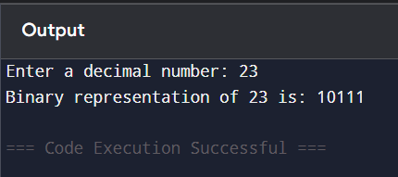

- Write a Java Program to find largest and smallest of n numbers.
import java.util.Scanner;

public class LargestSmallest {
public static void main(String[] args) {
Scanner sc = new Scanner(System.in);

System.out.print("Enter the number of elements: ");
int n = sc.nextInt();

int[] arr = new int[n];

System.out.println("Enter the elements:");
for (int i = 0; i < n; i++) {
arr[i] = sc.nextInt();
}

int largest = arr[0];
int smallest = arr[0];

for (int i = 1; i < n; i++) {
if (arr[i] > largest) {
largest = arr[i];
}
if (arr[i] < smallest) {
smallest = arr[i];
}
}

System.out.println("Largest number is: " + largest);
System.out.println("Smallest number is: " + smallest);

sc.close();
}
}

OUTPUT

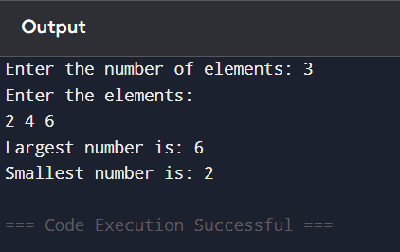

- Write a Java program that shows the application of constructors.
import java.util.Scanner;
// Class demonstrating constructors
class Person {
String name;
int age;
// Default constructor
Person() {
name = "Not Provided";
age = 0;
}
// Parameterized constructor
Person(String name, int age) {
this.name = name;
this.age = age;
}
// Method to display details
void showDetails() {
System.out.println("Name: " + name + ", Age: " + age);
}
}

public class Main {
public static void main(String[] args) {
Scanner sc = new Scanner(System.in);

// Using default constructor
Person p1 = new Person();
System.out.println("Object created using default constructor:");
p1.showDetails();

// Taking input from user
System.out.print("\nEnter your name: ");
String userName = sc.nextLine();
System.out.print("Enter your age: ");
int userAge = sc.nextInt();

// Using parameterized constructor
Person p2 = new Person(userName, userAge);
System.out.println("\nObject created using parameterized constructor:");
p2.showDetails();

sc.close();
}
}
OUTPUT
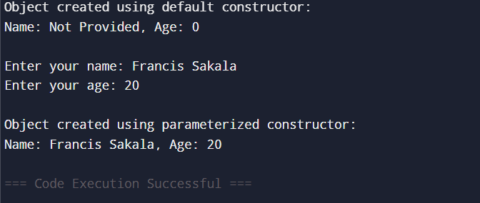

12 Write a Java program to find the electricity bill using inheritance
import java.util.Scanner;
// Base class
class Customer {
String name;
int units;
Customer(String name, int units) {
this.name = name;
this.units = units;
}
void showCustomer() {
System.out.println("Customer Name: " + name);
System.out.println("Units Consumed: " + units);
}
}
// Derived class
class ElectricityBill extends Customer {
double billAmount;
ElectricityBill(String name, int units) {
super(name, units); // Call parent constructor
billAmount = calculateBill();
}
// Method to calculate bill based on units
double calculateBill() {
double amount;
if (units <= 100) {
amount = units * 1.5; // Rs. 1.5 per unit
} else if (units <= 200) {
amount = (100 * 1.5) + (units - 100) * 2.0; // Rs. 2 per unit after 100
} else {
amount = (100 * 1.5) + (100 * 2.0) + (units - 200) * 3.0; // Rs. 3 per unit after 200
}
return amount;
}
void showBill() {
showCustomer(); // Display customer details from base class
System.out.println("Total Bill Amount: Rs. " + billAmount);
}
}
public class Main {
public static void main(String[] args) {
Scanner sc = new Scanner(System.in);
// Input from user
System.out.print("Enter customer name: ");
String name = sc.nextLine();
System.out.print("Enter units consumed: ");
int units = sc.nextInt();
// Create object of derived class
ElectricityBill eb = new ElectricityBill(name, units);
// Display bill
System.out.println("\n--- Electricity Bill ---");
eb.showBill();
sc.close();
}
}

OUTPUT
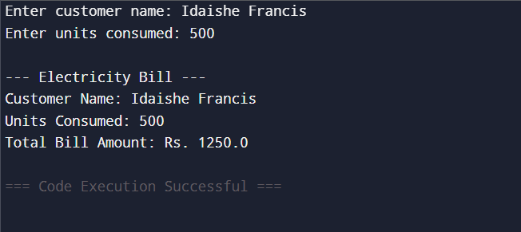

13.Write a program to count the number of objects created for a class using static member function
import java.util.Scanner;
// Class with static member to count objects
class Counter {
private static int count = 0; // shared across all objects
// Constructor increments count whenever a new object is created
Counter() {
count++;
}
// Static method to return number of objects created
public static int getCount() {
return count;
}
}

public class Main {
public static void main(String[] args) {
Scanner sc = new Scanner(System.in);
// Ask user how many objects to create
System.out.print("Enter the number of objects to create: ");
int n = sc.nextInt();
// Create 'n' objects
for (int i = 0; i < n; i++) {
new Counter();
}
// Display total number of objects created
System.out.println("Total number of objects created: " + Counter.getCount());
sc.close();
}
}
OUTPUT
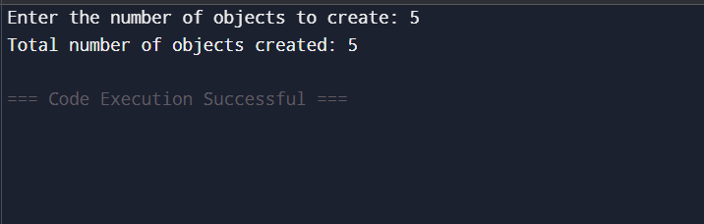

14.Create a class “Account” containing account No, and balance as an instance variable. Derive the Account class into two classes named “Savings” and “Current”. The “Savings” class should contain instance variable named interest Rate, and the “Current” class should contain instance variable called overdraft Limit. Define appropriate methods for all the classes to enable functionalities to check balance, deposit, and withdraw amount in Savings and Current account.
import java.util.Scanner;
// Abstract base class
abstract class Account {
int accountNo;
double balance;
Account(int accountNo, double balance) {
this.accountNo = accountNo;
this.balance = balance;
}
// Common methods
void checkBalance() {
System.out.println("Account No: " + accountNo + ", Balance: Rs. " + balance);
}
void deposit(double amount) {
balance += amount;
System.out.println("Deposited Rs. " + amount + ". New Balance: Rs. " + balance);
}
// Abstract method for withdrawal (implemented differently in subclasses)
abstract void withdraw(double amount);
}
// Savings account class
class Savings extends Account {
double interestRate;
Savings(int accountNo, double balance, double interestRate) {
super(accountNo, balance);
this.interestRate = interestRate;
}
@Override
void withdraw(double amount) {
if (amount <= balance) {
balance -= amount;
System.out.println("Withdrawn Rs. " + amount + ". New Balance: Rs. " + balance);
} else {
System.out.println("Insufficient balance in Savings Account!");
}
}
}
// Current account class
class Current extends Account {
double overdraftLimit;
Current(int accountNo, double balance, double overdraftLimit) {
super(accountNo, balance);
this.overdraftLimit = overdraftLimit;
}
@Override
void withdraw(double amount) {
if (amount <= balance + overdraftLimit) {
balance -= amount;
System.out.println("Withdrawn Rs. " + amount + ". New Balance: Rs. " + balance);
} else {
System.out.println("Withdrawal exceeds overdraft limit!");
}
}
}
public class Main {
public static void main(String[] args) {
Scanner sc = new Scanner(System.in);
// Choose account type
System.out.println("Choose account type: 1. Savings 2. Current");
int choice = sc.nextInt();
System.out.print("Enter Account Number: ");
int accNo = sc.nextInt();
System.out.print("Enter Initial Balance: ");
double balance = sc.nextDouble();
Account account = null;
if (choice == 1) {
System.out.print("Enter Interest Rate: ");
double rate = sc.nextDouble();
account = new Savings(accNo, balance, rate);
} else if (choice == 2) {
System.out.print("Enter Overdraft Limit: ");
double limit = sc.nextDouble();
account = new Current(accNo, balance, limit);
} else {
System.out.println("Invalid choice!");
sc.close();
return;
}
// Perform operations
account.checkBalance();
System.out.print("\nEnter amount to deposit: ");
double depositAmt = sc.nextDouble();
account.deposit(depositAmt);
System.out.print("\nEnter amount to withdraw: ");
double withdrawAmt = sc.nextDouble();
account.withdraw(withdrawAmt);
account.checkBalance();
sc.close();
}
}
OUTPUT
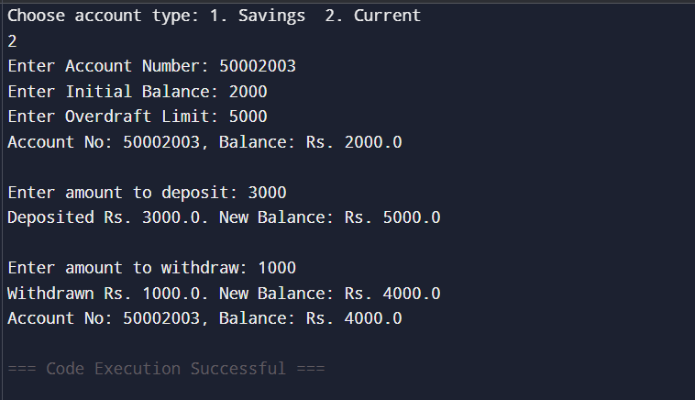
15.Write a program to demonstrate the use of ‘this’ and ‘static’ keyword.
import java.util.Scanner;
// Class representing a Bank Account
class Account {
private int accountNo;
private String holderName;
private double balance;
// Static variable to count number of accounts created
private static int accountCount = 0;
// Constructor using 'this' keyword
Account(int accountNo, String holderName, double balance) {
this.accountNo = accountNo; // 'this' refers to current object
this.holderName = holderName;
this.balance = balance;
accountCount++; // increment static counter
}
// Instance method using 'this'
void deposit(double amount) {
this.balance += amount; // 'this' clarifies we mean object's balance
System.out.println("Deposited Rs. " + amount + ". New Balance: Rs. " + this.balance);
}
void withdraw(double amount) {
if (amount <= this.balance) {
this.balance -= amount;
System.out.println("Withdrawn Rs. " + amount + ". New Balance: Rs. " + this.balance);
} else {
System.out.println("Insufficient balance!");
}
}
void checkBalance() {
System.out.println("Account No: " + this.accountNo + ", Holder: " + this.holderName + ", Balance: Rs. " + this.balance);
}
// Static method to show number of accounts created
public static void showAccountCount() {
System.out.println("Total Accounts Created: " + accountCount);
}
}
public class Main {
public static void main(String[] args) {
Scanner sc = new Scanner(System.in);
// Take user input for first account
System.out.print("Enter Account Number: ");
int accNo1 = sc.nextInt();
sc.nextLine(); // consume newline
System.out.print("Enter Account Holder Name: ");
String name1 = sc.nextLine();
System.out.print("Enter Initial Balance: ");
double bal1 = sc.nextDouble();
Account a1 = new Account(accNo1, name1, bal1);
// Perform operations
a1.checkBalance();
System.out.print("\nEnter amount to deposit: ");
double dep = sc.nextDouble();
a1.deposit(dep);
System.out.print("\nEnter amount to withdraw: ");
double wd = sc.nextDouble();
a1.withdraw(wd);
a1.checkBalance();
// Create another account to show static counter
Account a2 = new Account(102, "Second User", 5000);
// Show total accounts created using static method
Account.showAccountCount();
sc.close();
}
}

OUTPUT
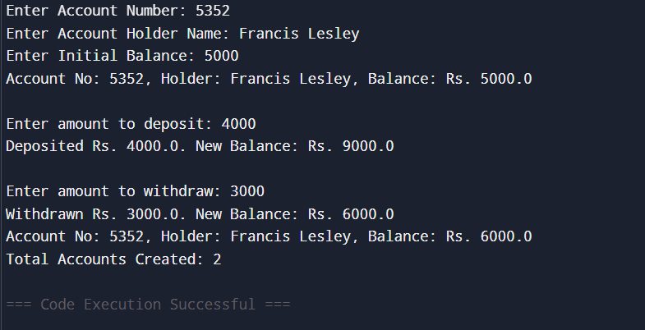
16.Describe abstract class called Shape which has three subclasses say Triangle, Rectangle, and Circle. Define one method area () in the abstract class and override this area () in these three subclasses to calculate for specific object i.e. area () of Triangle subclass should calculate area of triangle etc. Same for Rectangle and Circle.
import java.util.Scanner;
// Abstract base class
abstract class Shape {
// Abstract method to be implemented by subclasses
abstract double area();
}
// Triangle subclass
class Triangle extends Shape {
double base, height;
Triangle(double base, double height) {
this.base = base;
this.height = height;
}
@Override
double area() {
return 0.5 * base * height;
}
}
// Rectangle subclass
class Rectangle extends Shape {
double length, width;
Rectangle(double length, double width) {
this.length = length;
this.width = width;
}
@Override
double area() {
return length * width;
}
}
// Circle subclass
class Circle extends Shape {
double radius;

Circle(double radius) {
this.radius = radius;
}
@Override
double area() {
return Math.PI * radius * radius;
}
}
public class Main {
public static void main(String[] args) {
Scanner sc = new Scanner(System.in);
System.out.println("Choose a shape to calculate area:");
System.out.println("1. Triangle");
System.out.println("2. Rectangle");
System.out.println("3. Circle");
int choice = sc.nextInt();
Shape shape = null;
switch (choice) {
case 1:
System.out.print("Enter base of triangle: ");
double base = sc.nextDouble();
System.out.print("Enter height of triangle: ");
double height = sc.nextDouble();
shape = new Triangle(base, height);
break;
case 2:
System.out.print("Enter length of rectangle: ");
double length = sc.nextDouble();
System.out.print("Enter width of rectangle: ");
double width = sc.nextDouble();
shape = new Rectangle(length, width);
break;
case 3:
System.out.print("Enter radius of circle: ");
double radius = sc.nextDouble();
shape = new Circle(radius);
break;
default:
System.out.println("Invalid choice!");
sc.close();
return;
}
// Display area
System.out.println("Area: " + shape.area());
sc.close();
}
}
OUTPUT
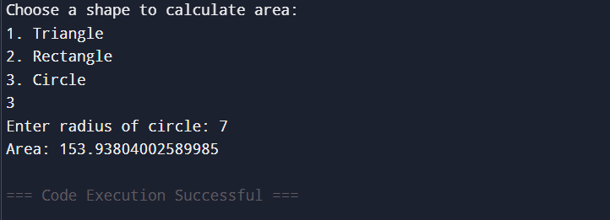
17.Write a java program to find the result sheet of a student using Interfaces.
import java.util.Scanner;
// Interface defining result-related behavior
interface Result {
void calculateResult();
void displayResult();
}

// Encapsulated Student class
class Student implements Result {
private int rollNo;
private String name;
private int[] marks;
private double percentage;
private String grade;
// Constructor
Student(int rollNo, String name, int[] marks) {
this.rollNo = rollNo;
this.name = name;
this.marks = marks;
}
// Implement interface methods
@Override
public void calculateResult() {
int total = 0;
for (int mark : marks) {
total += mark;
}
percentage = (double) total / marks.length;
if (percentage >= 90) {
grade = "A+";
} else if (percentage >= 75) {
grade = "A";
} else if (percentage >= 60) {
grade = "B";
} else if (percentage >= 40) {
grade = "C";
} else {
grade = "Fail";
}
}
@Override
public void displayResult() {
System.out.println("\n--- Student Result Sheet ---");
System.out.println("Roll No: " + rollNo);
System.out.println("Name: " + name);
System.out.print("Marks: ");
for (int mark : marks) {
System.out.print(mark + " ");
}
System.out.println("\nPercentage: " + percentage + "%");
System.out.println("Grade: " + grade);
}
}
public class Main {
public static void main(String[] args) {
Scanner sc = new Scanner(System.in);
// Input student details
System.out.print("Enter Roll No: ");
int rollNo = sc.nextInt();
sc.nextLine(); // consume newline
System.out.print("Enter Name: ");
String name = sc.nextLine();
System.out.print("Enter number of subjects: ");
int n = sc.nextInt();
int[] marks = new int[n];
for (int i = 0; i < n; i++) {
System.out.print("Enter marks for subject " + (i + 1) + ": ");
marks[i] = sc.nextInt();
}
// Create Student object
Student student = new Student(rollNo, name, marks);
// Calculate and display result
student.calculateResult();
student.displayResult();
sc.close();
}
}
OUTPUT
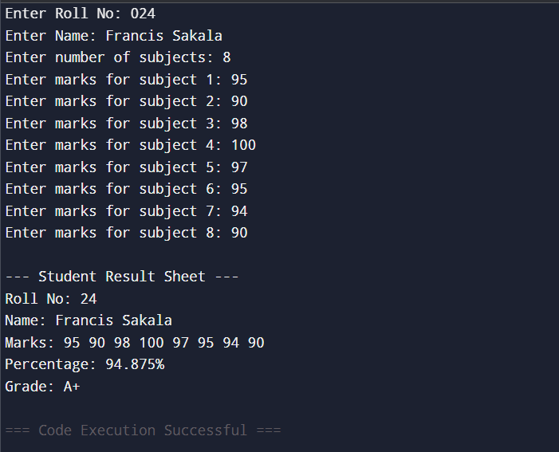
18 Write a java program which shows importing of classes from other packages.
// Demonstration of importing classes from other packages
// Importing built-in package class
import java.util.Scanner;
// Define a package-like class (normally this would be in another file/package)
class MyUtility {
public void greet(String name) {
System.out.println("Hello, " + name + "! Welcome to the package demo.");
}
}
public class Main {
public static void main(String[] args) {
// Using imported Scanner class from java.util package
Scanner sc = new Scanner(System.in);
System.out.print("Enter your name: ");
String name = sc.nextLine();
// Using our user-defined class (simulating import from another package)
MyUtility util = new MyUtility();
util.greet(name);
sc.close();
}
}
OUTPUT
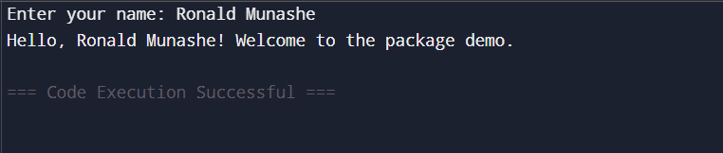

19 Assume that there are two packages, student and exam. A student package contains Student class and the exam package contains Result class. Write a program that generates mark sheet for students.
// Demonstration of using classes from different packages in one file
// (Simulated for online compiler)

import java.util.Scanner;

// Simulated "student" package class
class Student {
private int rollNo;
private String name;

public Student(int rollNo, String name) {
this.rollNo = rollNo;
this.name = name;
}

public int getRollNo() {
return rollNo;
}

public String getName() {
return name;
}
}

// Simulated "exam" package class
class Result {
private Student student;
private int[] marks;
private double percentage;
private String grade;

public Result(Student student, int[] marks) {
this.student = student;
this.marks = marks;
calculate();
}

private void calculate() {
int total = 0;
for (int m : marks) {
total += m;
}
percentage = (double) total / marks.length;

if (percentage >= 90) grade = "A+";
else if (percentage >= 75) grade = "A";
else if (percentage >= 60) grade = "B";
else if (percentage >= 40) grade = "C";
else grade = "Fail";
}

public void display() {
System.out.println("\n--- Mark Sheet ---");
System.out.println("Roll No: " + student.getRollNo());
System.out.println("Name: " + student.getName());
System.out.print("Marks: ");
for (int m : marks) {
System.out.print(m + " ");
}
System.out.println("\nPercentage: " + percentage + "%");
System.out.println("Grade: " + grade);
}
}

public class Main {
public static void main(String[] args) {
Scanner sc = new Scanner(System.in);

// Input student details
System.out.print("Enter Roll No: ");
int rollNo = sc.nextInt();
sc.nextLine(); // consume newline
System.out.print("Enter Name: ");
String name = sc.nextLine();

System.out.print("Enter number of subjects: ");
int n = sc.nextInt();
int[] marks = new int[n];

for (int i = 0; i < n; i++) {
System.out.print("Enter marks for subject " + (i + 1) + ": ");
marks[i] = sc.nextInt();
}
// Create Student and Result objects
Student student = new Student(rollNo, name);
Result result = new Result(student, marks);
// Display mark sheet
result.display();
sc.close();
}
}
OUTPUT
